Step 1: For publishing a product on Google cloud go to Marketplace.
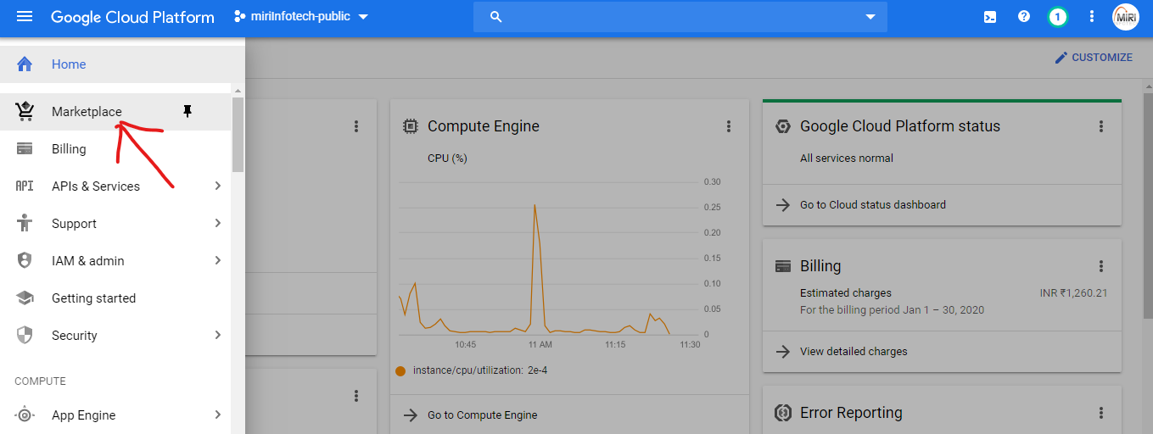
Step 2: Then click on Partner Portal.
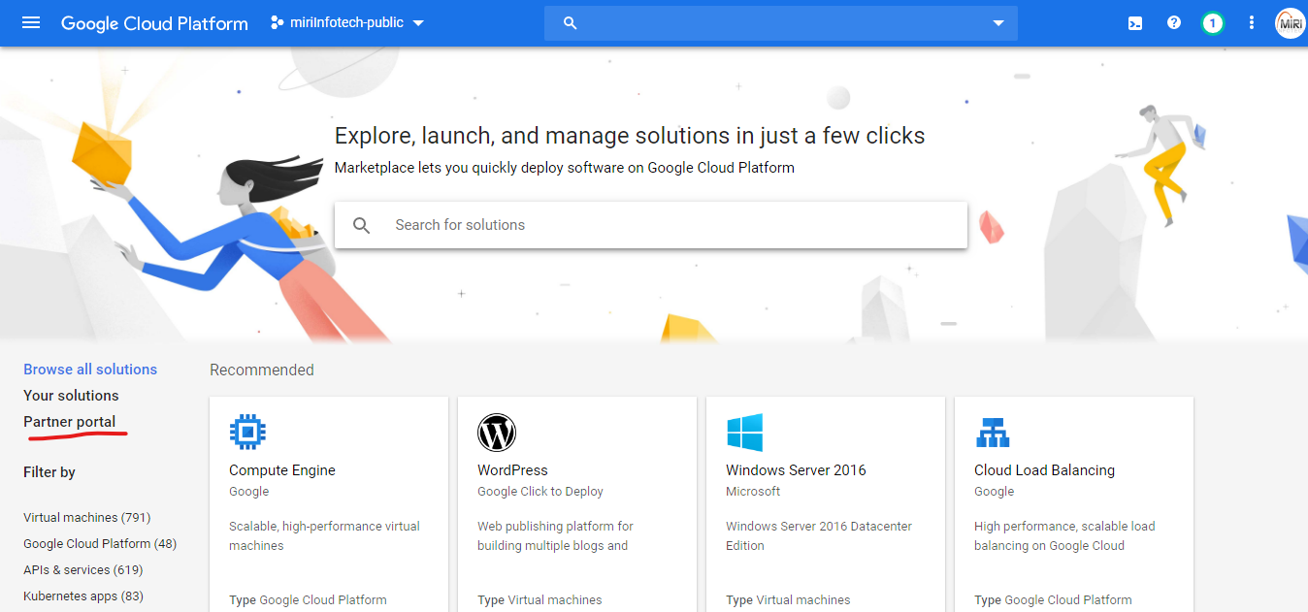
Step 3: Then click on ADD Solution if you want to add a new product or if you already have created the solution select the one you want to update.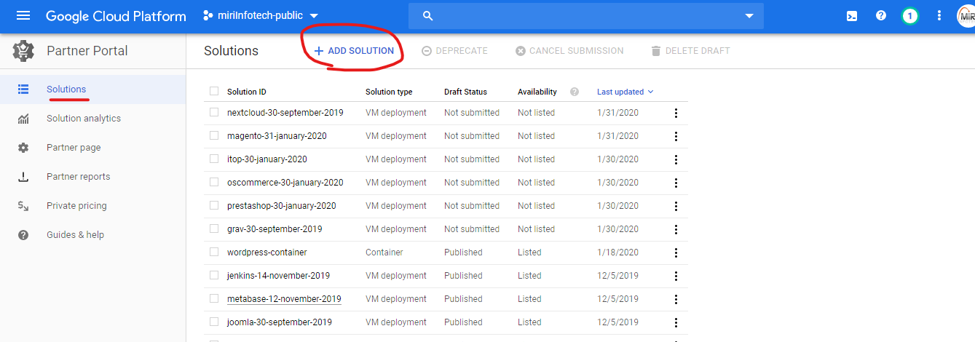

Step 4: A dialog box will appear give a solution name as per convention i.e. (wordpress-31-january-2020)
Which is same as license name.
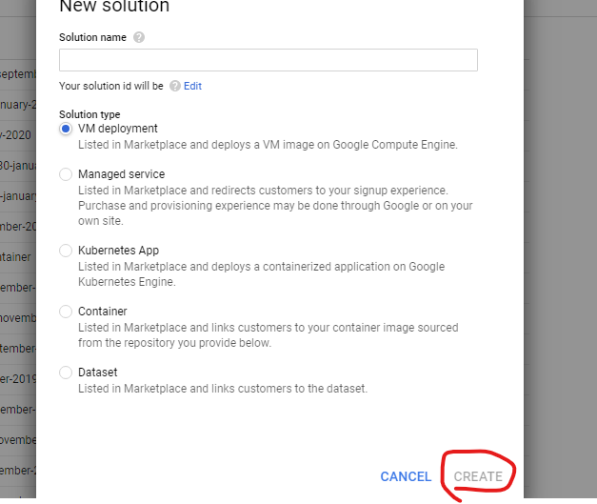
Now see the fields which are not checked with blue ticks, you need to edit those field and click on save.

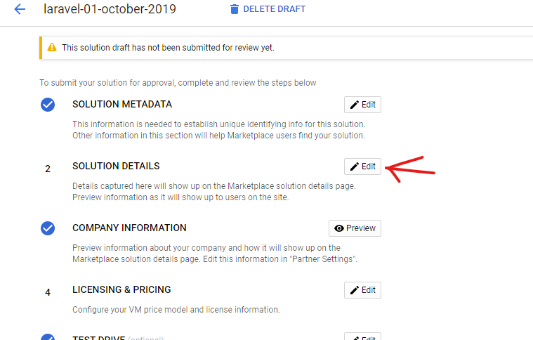

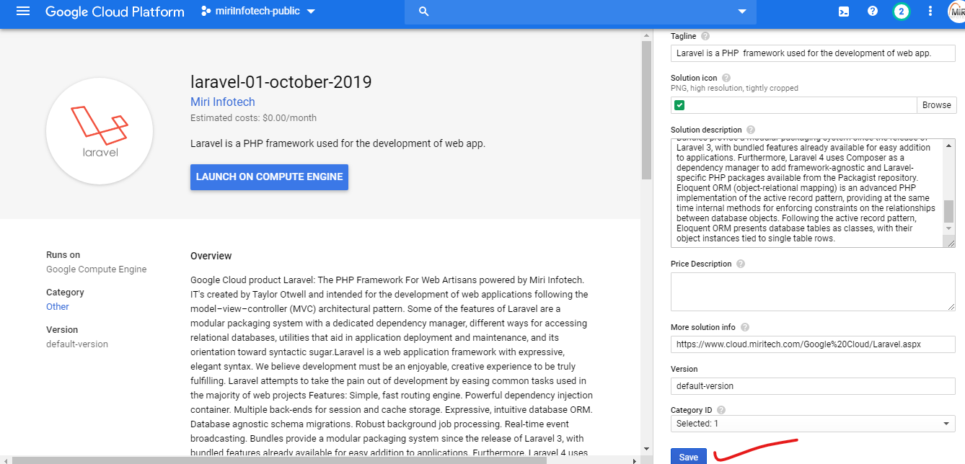
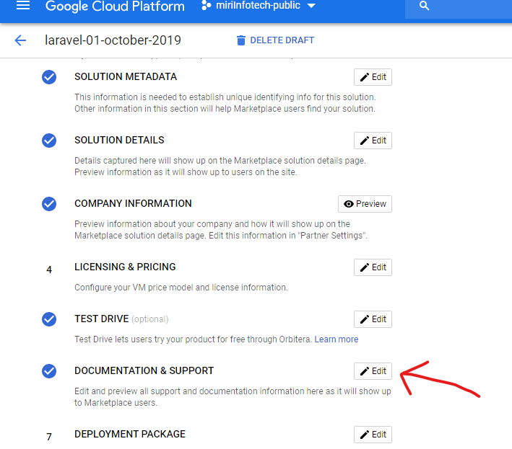
Now you need to enter links of your deployment instruction page and support page.
To enter a deployment instruction, you need to click on add document button and then enter the required field as shown below.
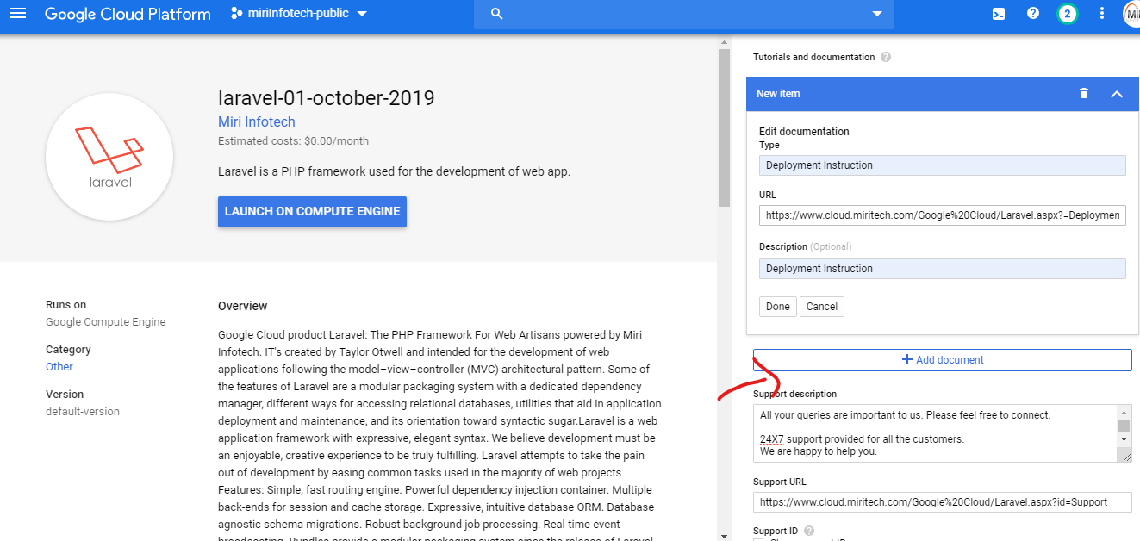

https://www.cloud.miritech.com/Google%20Cloud/Laravel.aspx?=DeploymentInstructions
https://www.cloud.miritech.com/Google%20Cloud/Laravel.aspx?id=Support
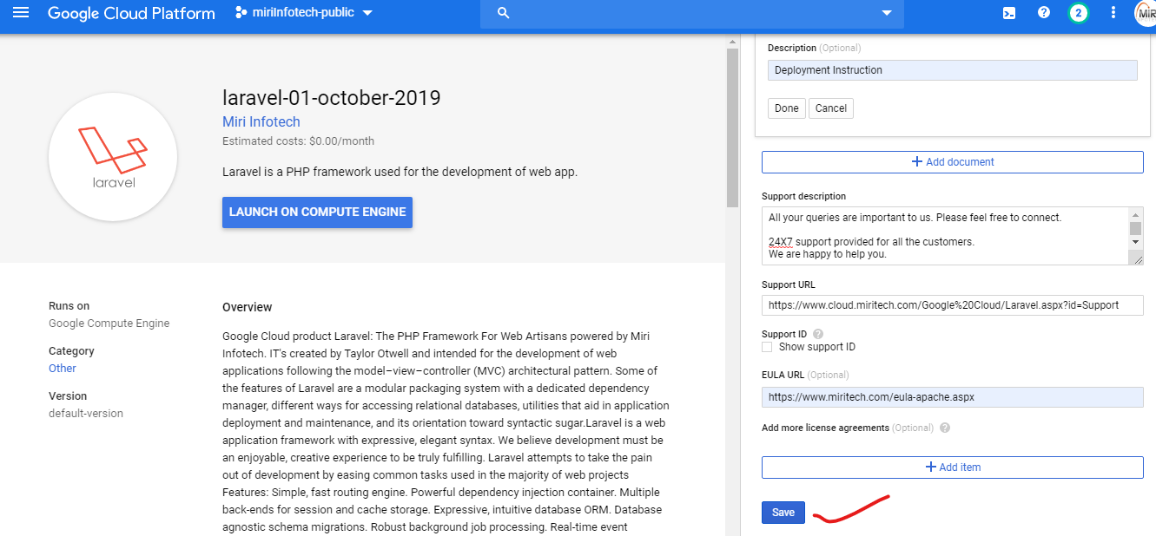

Now you need to edit the default deployment package on which a user can create a vm.
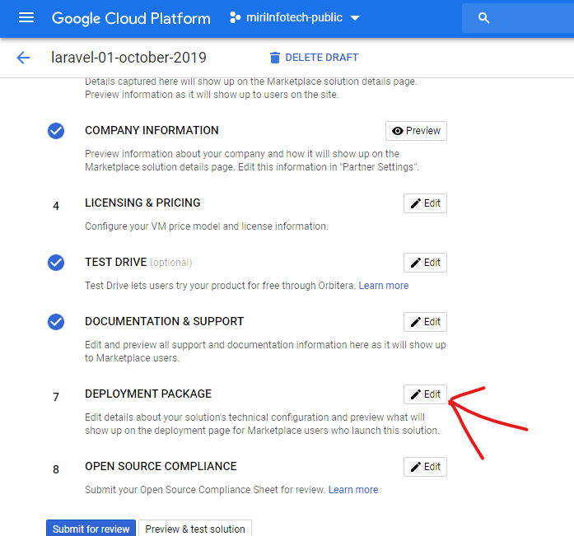

Follow the instructions as shown below,

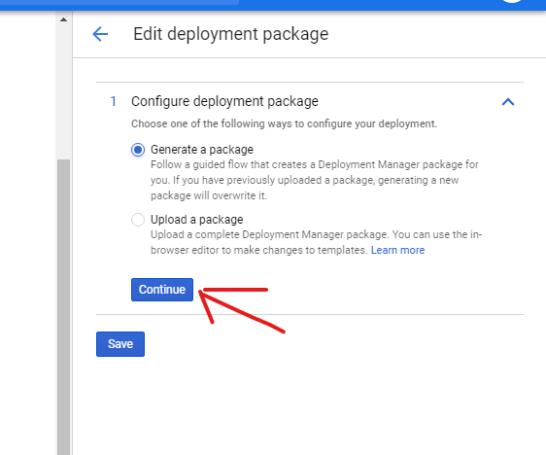
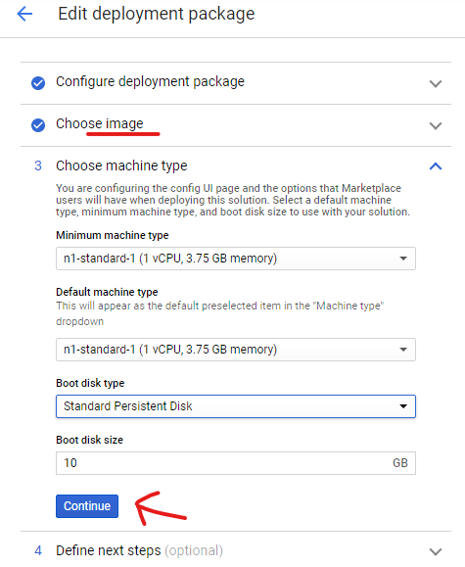
Leave the fields as it is which are marked as optional and choose the os version on which you have configured your product.
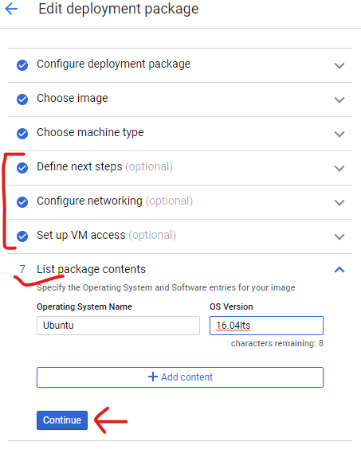
Then click on save.
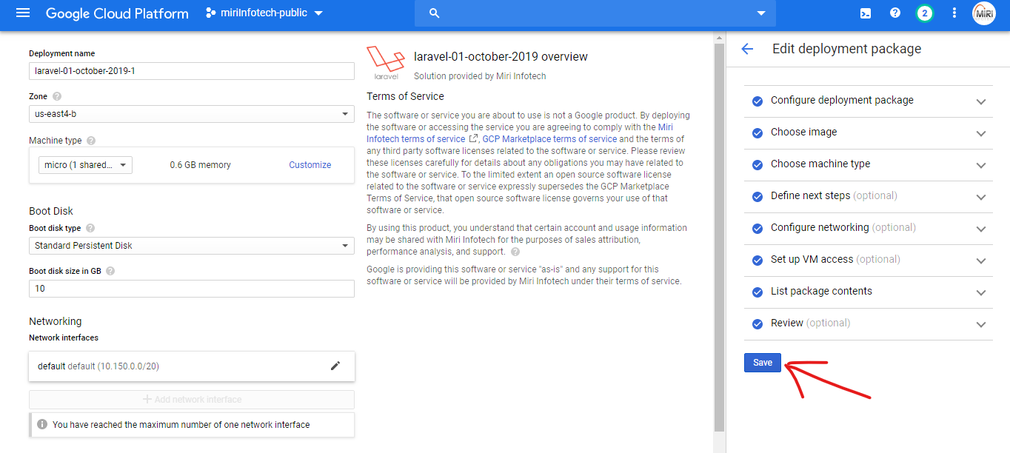
Next comes the open source compilation sheet, it’s a google sheet on which you need to specify details of your software. To do that follow the steps shown below,
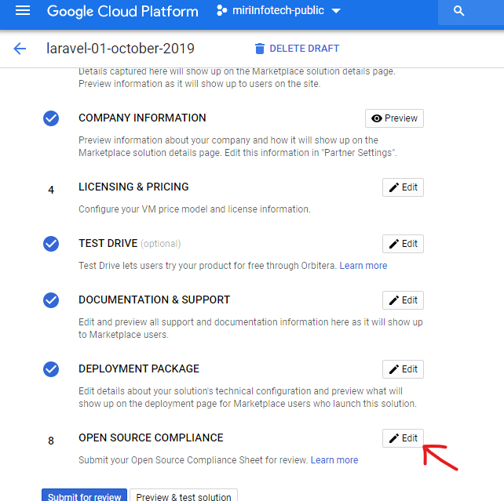

Click on make a copy, a google excel sheet will open fill in the details as follows,

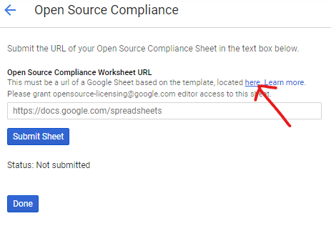
There are three sheets so fill each one according to your product,

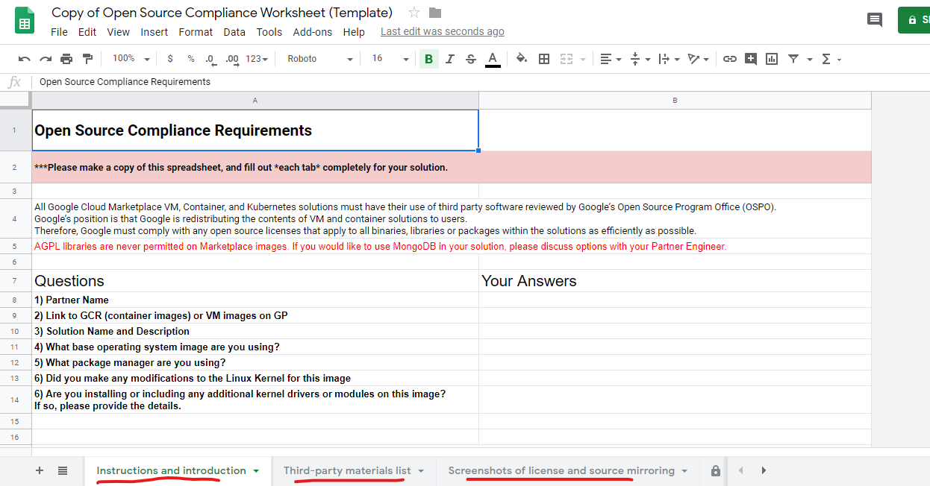

Copy url of your product image from google console

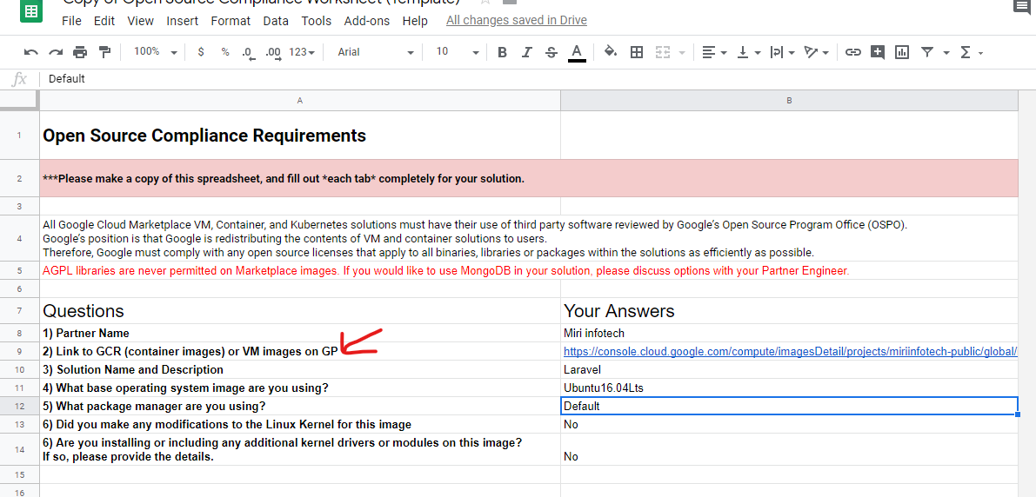
Copy url of your product image from google console,
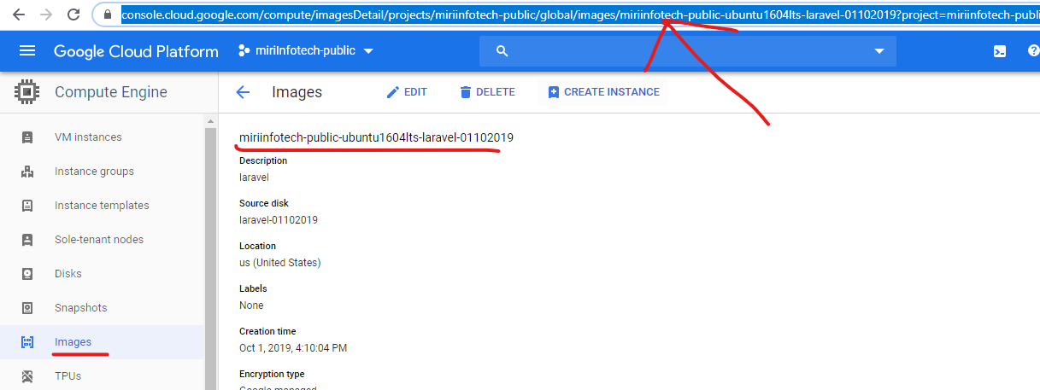

You need to search for license of your product on web and then copy the url from there and then enter name of product, link to license file, type of license, and other two fields as yes.

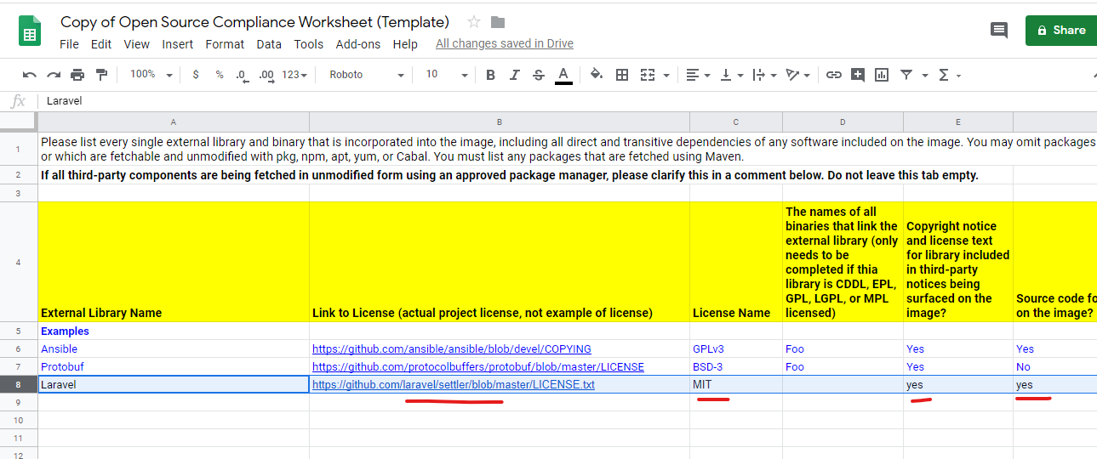

Now insert the license path screenshot (1) of product that we took during product creation.
And in next cell insert path of source code screenshot (2).
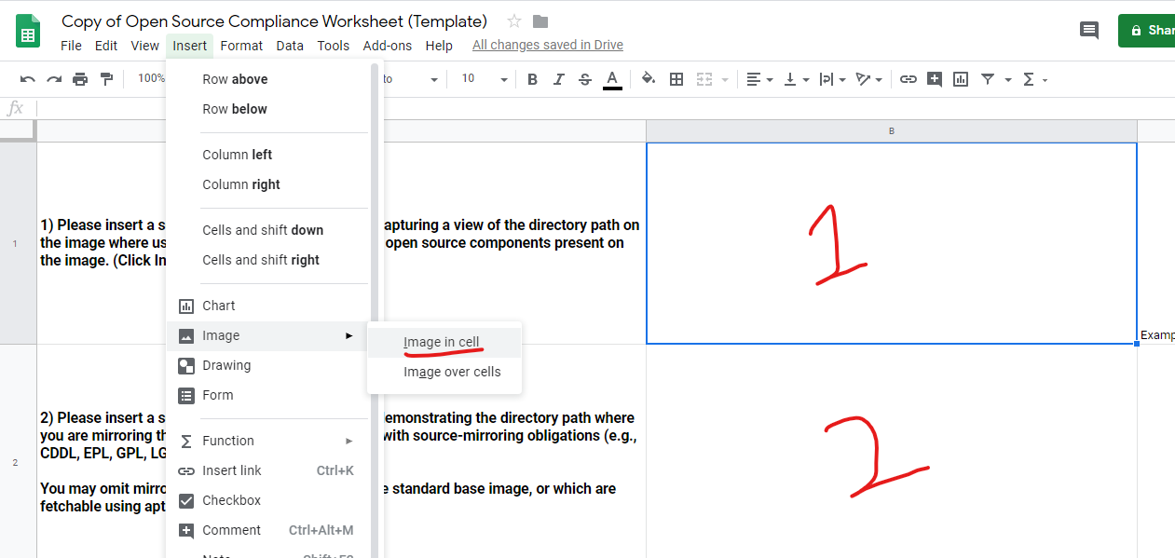

Once all the 3 google sheets are completed click on share and get a shareable link of your google sheet.
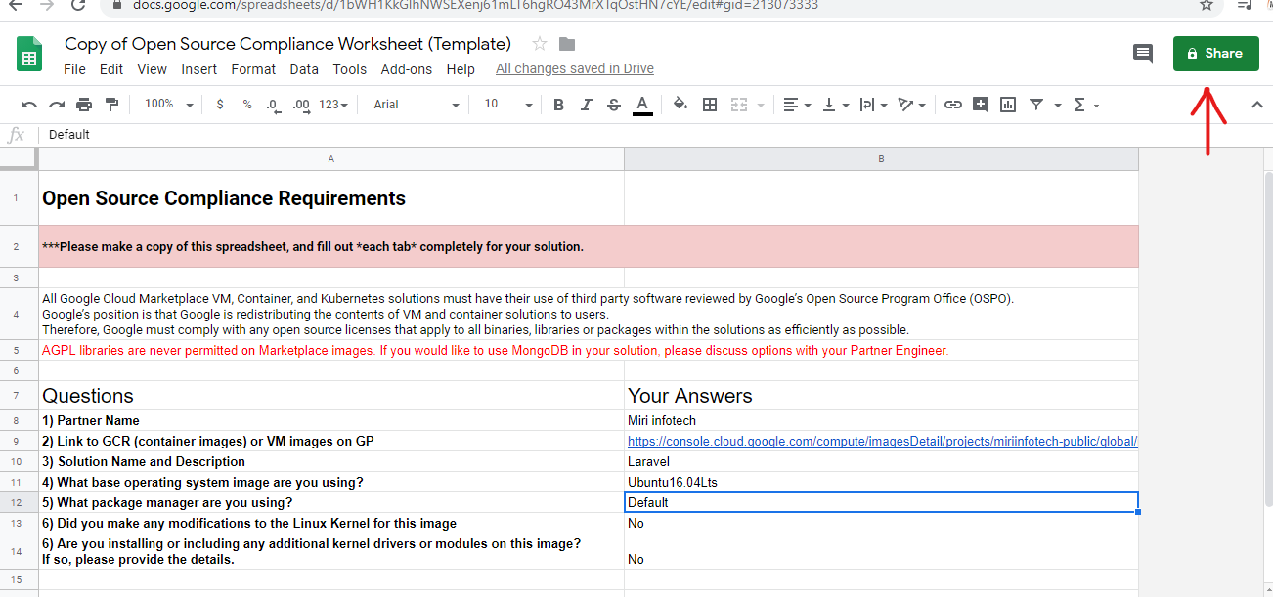

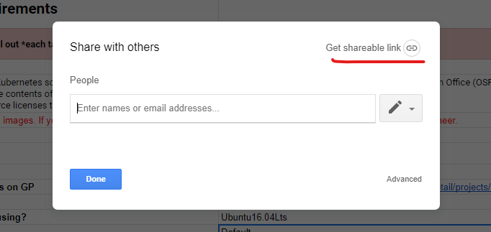

Now paste the sharable link on given field open source worksheet url,

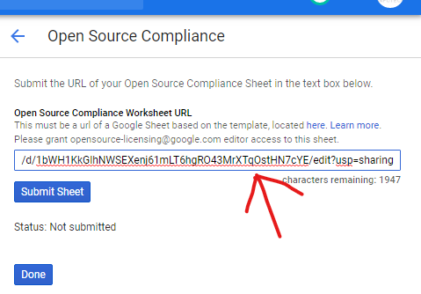
Once you are done with google sheet submit your sheet for review and click on done.
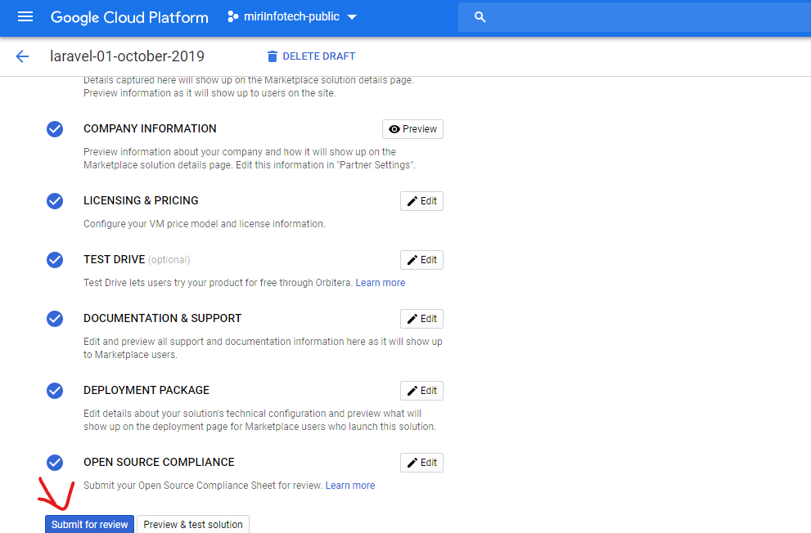
Now when all the fields have been competed you can submit your solution for review.

